Profile Statement for Linda Jones

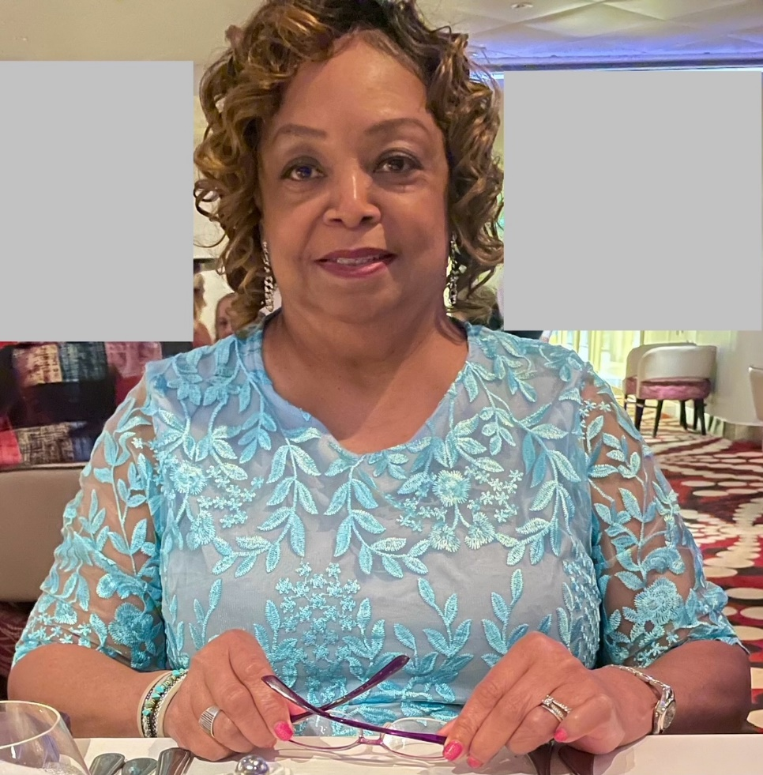

Hi, my name is Linda. I am a born-again believer in Jesus Christ.  I am also a wife of 41 years, the mother of an adult son and grandmother of eight. Prior to retirement, I worked in the financial world of in two different industries, totaling 40 years of service. I have experience in clerical and managerial skill sets.

My life experience has taught me how important prayer is in the life of a believer.  In my spare time, I currently volunteer as a childcare teacher in a Christian ministry that works with immigrants and refugees. I also participant in an ongoing Bible study with a neighbor.

Linda comes to us from the “Buck-eye” state of Ohio, and is the organization Secretary for Berdoa International Prayer Ministries.