Profile Statement

Mrs. Stefany Noble

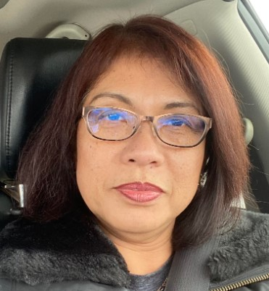

Hi, my name Stefany Noble and I was born in Central Java-Indonesia of Chinese decent. I’m a Christ follower, wife of 35 years, a mother of two, and a loving “doggie mom” named Lucy Lu. Prayer is a daily communication between myself and my heavenly father. Growing up in Indonesia as a child, I struggled with the discrimination of being Chinese. I became a citizen of the United States of America in 1995 with the hope of a brighter future where all persons were treated fairly.

Stefany is a Trustee and a Board Chairwoman, she comes to us from the Buckeye state of Ohio with an extensive background in Management and Human Resources. Stefany enjoys traveling, cooking, and taking care of small children. Her signature dish is tiramisu, and made it to the Cleveland finals for MasterChef.