Profile Statement

Rev. Russell Noble

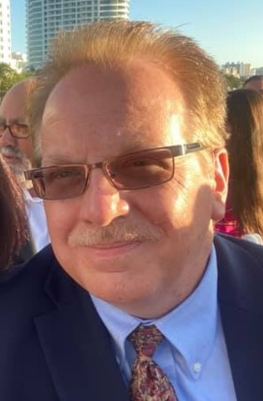

Rev. Russell Noble is our Founding Trustee and Executive Director. A Christian since he was 8 years old, married for 35 years, and is the father of two children- Sabrina Mears and Regina “Dani” Noble. He has a Bachelor's degree in Theology with a Counseling Certificate in Pastoral Counseling from Liberty Christian College and continued studies at Lincoln Christian University for an MA in Intercultural Studies. He has been an Ordained Minister for the Christian Church and Churches of Christ since 1991. He comes to us from The Land of Lincoln, Illinois born in the twin cities of Bloomington-Normal. He likes to say he is “probably the most Normal person you will ever meet”. He was a Missionary to Indonesia, and has preached in several churches throughout Southeast Asia, where he had the opportunity to nurture, organize, and form five churches. His passion for the uneducated, homeless, hungry, and those disconnected by sin, keeps him reaching out to be the hands of Christ extended. He recalls a college Internship at Chicago's Pacific Garden Mission in this way: *I spent many sub-zero nights wandering the dark streets of Chicago under the by-passes and bridges calling out the names of those I knew would never come inside for shelter; still, I called aloud as Jesus searching for one lost sheep.*