Profile Statement

Mrs. Kimberly Carter

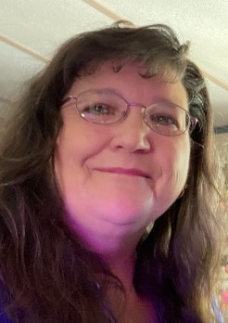

Hi I'm Kimberly, I grew up on a farm in Iowa and I attended The United Methodist Church. I sang in the choir in high school, and helped teach VBS, but at home my environment was far from Christ-like. I was sexual assaulted, violation and abused in an environment that was suppose to be safe- my home. The people that God entrusted me with as guardians, became perpetrators intentionally inflicting harm on me physically, psychologically, and sexually. My life would be forever scared, and even as an adult the additional challenges of adapting lingered into my married life. While my husband's church gave a transforming presentation that introduced me to Jesus Christ, I still had a lot of trauma to walk out. It would be many years later, after marrying again for the third time before I would learn what the Prophet Jeremiah prayed about in Jeremiah 8:22, Jeremiah asks, “Is there no balm in Gilead, Is there no physician there? Why then is there no recovery for the health of the daughter of my people?” That healing ointment was prophetically symbolized as the crucified person of Jesus Christ. Spoken again in Isaiah 53:5, and was the healing salve that would roll over my deepest wounds. Like Mary Magdalene, I have been forgiven of much and have sought to serve in every opportunity.

Kim is our Director of Pastoral Counseling Services, comes to us originally from the Hawkeye State, Iowa but currently lives in Georgia.