Profile Statement

Mrs. Hellena Beal

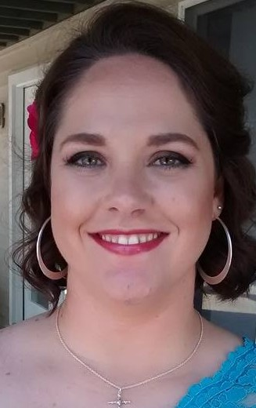

Hello, my name is Hellena Beal and I am a mother of a teenage son and a wife for almost 19 years. I have been involved in a retreat for women in our community (and the surrounding towns) for several years, I enjoy it very much. I have also served in the chapel of the women's prison near us, while doing a similar retreat. I love to minister in the chapel enviroment praying for others, and spending intimate time with God. Prayer should be a time to calm yourself, and talk directly to God about the things going on in your heart. I invite you to give it a try, you might be surprised at the results.

Hellena comes to us from The Land of Lincoln, and is an Officer in a shared position as

Director of Licensed Chaplaincy Recruitment. She is a tremendous assest to us with a servant’s heart and a love for the simple things of life.