Profile Statement

Mrs. Christina Steiders

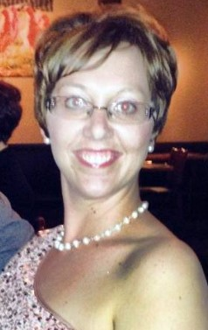

My name is Christina Steider, and I am a blessed wife, and mother with a 20 year old daughter, an 18 year old son, and a16 year old daughter. I thankfully met Jesus as a young single mother, after every broken relationship in my life had led me to a personal relationship with Christ. It is through this personal relationship that I have experienced the love of my heavenly Father best. It’s through my intimate relationship with God that I have learned to love those around me. Christina is currently employed as a Coordinator of Student Access and Accommodation Services for the Community College in her area, and takes great pleasure as a Board member of the Northwestern Missions International President representative and Sunday school teacher of her church’s organation. Her focus has been to create an equitable, diverse and an inclusive environment for all persons.

Christina comes to us from The Land of Lincoln, Illinois and she is a Trustee and an Officer in a shared position as Director of Licensed Chaplaincy Recruitment. She is a talented woman of faith, with a heart to serve God.